CHAPTER FOUR:

SYSTEM IMPLEMENTATION AND TESTING

4.1 Implementation Framework Nowadays, many frameworks have been developed for deep learning. Some of the most popular ones include libraries such as: Kerras, Kernel, OpenCV, NUNPY, Jupiter, Spider, Theano, TensorFlow . Also, implementing a framework from scratch using a programming language was never considered. It would have been out of scope since it requires a big amount of effort, and the duration of such a project usually takes years. The use of Java as the front-end API on all these frameworks shows that it is the preferred language for machine learning. Usually, Java is combined with a programming language that provides support for low level operations such as: C or C++, to act on the back end.

4.2 Frameworks

4.2.2 Theano: Theano has its origin on the Montreal Institute for Learning Algorithms at the University of Montral. Nowadays, it has become an open source project with a big community. Theano is a Python-library that has the ability to produce CPU or GPU instructions for some graph computations. The performance of these instructions is closer to the one provided by C, and it is much faster than pure Python.

4.2.3 TensorFlow: TensorFlow (TF) is an open source software library for machine learning written in Python and C++. Its release some months ago (Nov 15) had a strong press coverage. The main reason behind it is that TF was developed by Google Brain Team. Google has already been using TF to improve some tasks on several products. These tasks include speech recognition in Google Now, search features in Google Photos, and the smart reply feature in Inbox by Gmail.

4.2.4 Kerras: Keras is an open-source software library that provides a Python interface for artificial neural networks. Keras acts as an interface for the TensorFlow library. 39

4.2.6 OpenCV: OpenCV is a library of programming functions mainly aimed at real-time com

4.2.9 Apache Netbeans: bean, Java Development Environment, is a free integrated development environment (IDE) that is included with Multiple frameworks. It includes editing, interactive testing, debugging, and introspection features

4.3 Implementation Details

This system that was developed was built in Java with Opencv framework which incorporated different compilers for smooth and efficient running of Java programs. Java programming language was chosen as the best language of choice for this particular program, this was observed as a result of java being the most efficient and typed programming language in image processing or computer vision task. Difference libraries were required to incorporated with the system such as OpenCV, TensorFlow, etcetera., for this reason a lot of libraries were used for letting the program become success.

NETBEANS Image —----------------------------------------------------

This is the interface of “Apache Netbeans” which include difference compilers and as one of the compiler which simplify the works of computer vision

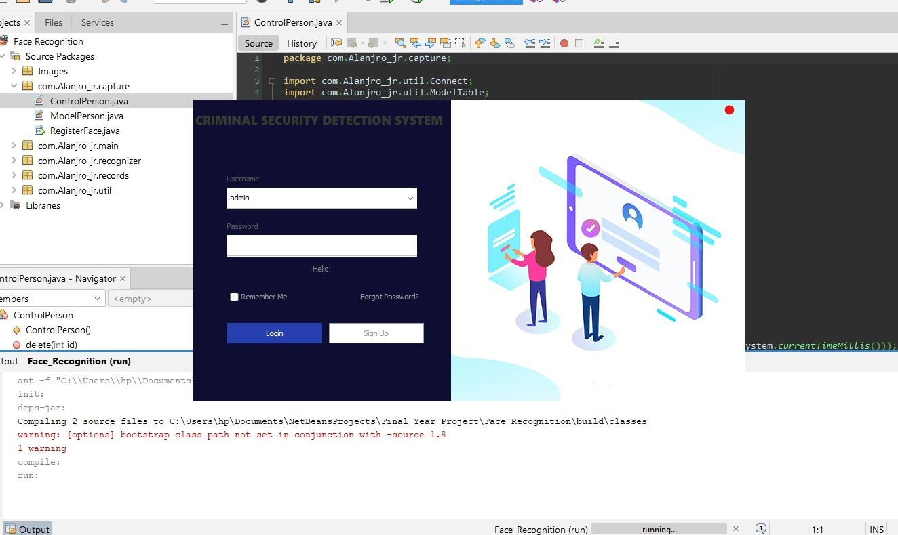

The login authorization page of a Face Recognition Security System serves as the initial access point, ensuring secure entry into the system. Users are required to authenticate themselves , adding an extra layer of security.

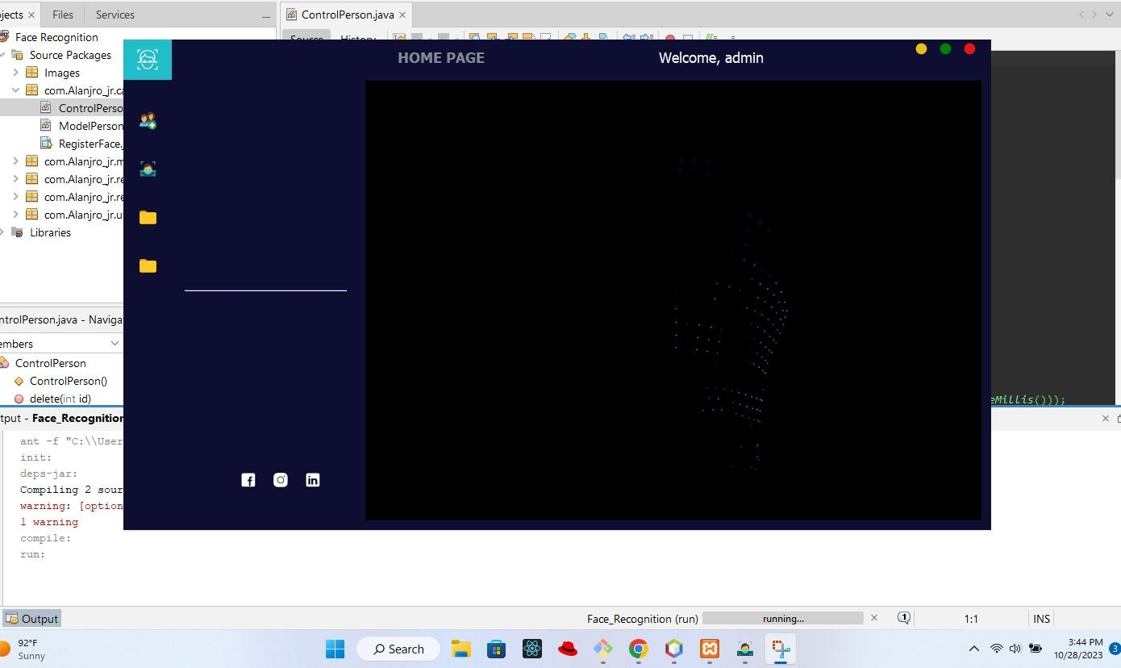

The homepage of the Face Recognition Security System features user-friendly options for New Enrollment, the Recognizer Page for quick identity verification, and a centralized Data or Registered Faces Page for convenient management of stored facial data.

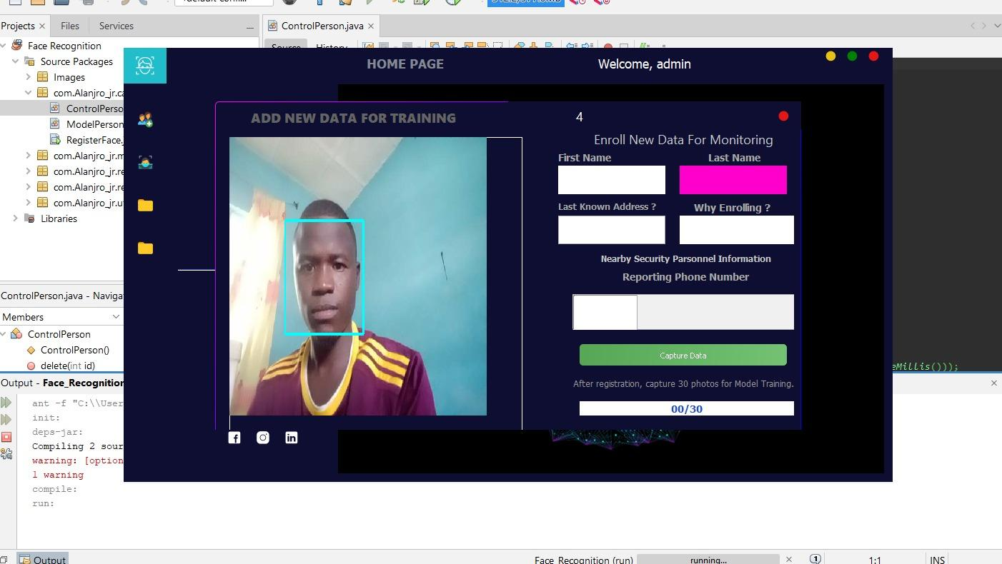

The Enrollment Page of the Face Recognition Security System incorporates essential Client details, including the client's name and the reason for registering, along with an option to provide a nearby security contact number. Additionally, the page allows for live photo capture through the webcam, ensuring real-time facial data input, and includes a convenient "Save" button for secure storage and registration.

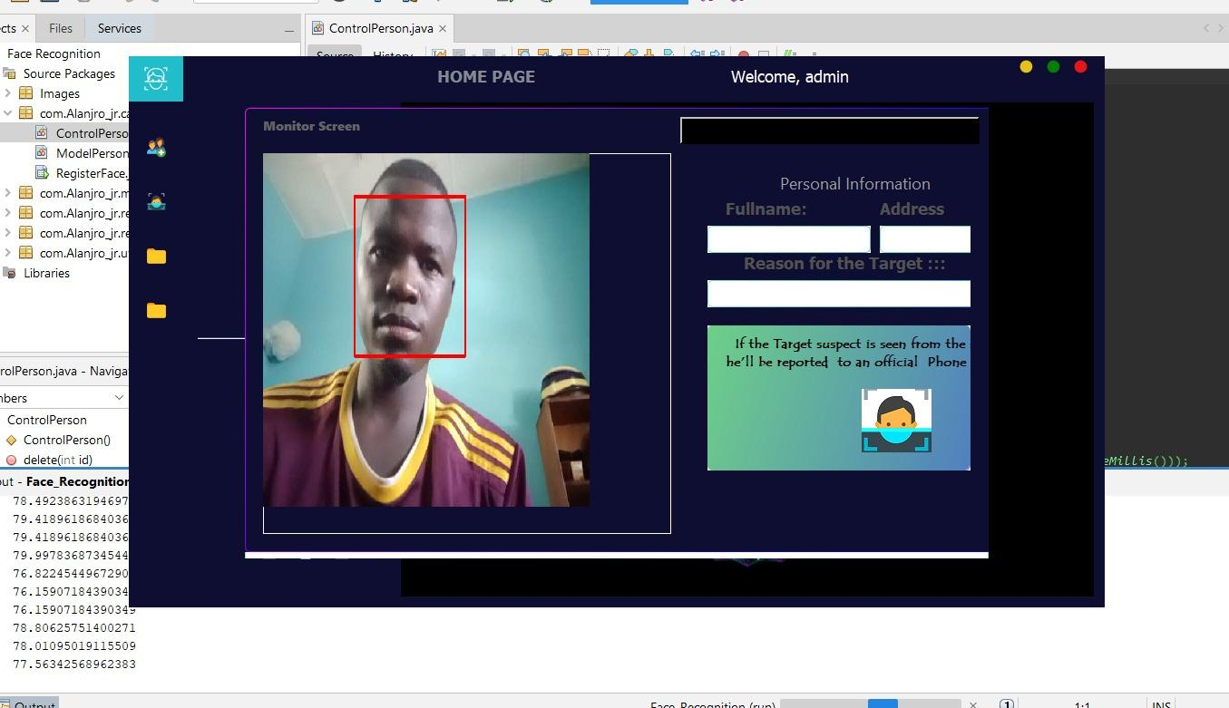

The Recognizer Page of the Face Recognition Security System displays key information, including the recognized individual's name and photo. It features an SMS notification functionality to alert Nearby Security PErsonnel. For visual clarity, a green box surrounds the image for recognized faces, while a red box indicates unrecognized individuals, enhancing quick and intuitive identification.